Task 1: Myntra Network Request & Cache Analysis

1. Objective
The objective of this task is to understand how a web browser communicates with a web server when a user opens a website and clicks on a product.
In this task, Myntra is used as an example. Chrome DevTools' Network panel is used to observe the requests made by the browser when a product page is opened.
The main objectives are:
- To understand how a browser communicates with a web server.
- To observe network requests generated when a product is opened.
- To identify different types of resources such as HTML, CSS, JavaScript, images, and API/fetch requests.
- To understand the difference between resources loaded from the server/network and resources loaded from the browser cache.
- To learn how Chrome DevTools can be used to analyze website performance and network activity.

2. Step-by-Step Procedure

Step 1: Open Google Chrome
Open Google Chrome on a Windows 11 computer.
Navigate to:
Myntra: https://www.myntra.com

Step 2: Open Chrome Developer Tools
Right-click anywhere on the Myntra webpage.
Select:
Inspect
Alternatively, you can press:
F12 or Ctrl + Shift + I
Chrome Developer Tools will open.

Step 3: Open the Network panel
In Chrome DevTools, select the:
Network
tab.
The Network panel records network activity generated by the webpage. It displays requests for documents, images, CSS files, JavaScript files, APIs, fonts, and other resources.

Step 4: Enable Preserve log
At the top of the Network panel, enable:
☑ Preserve log
This keeps the network requests visible even when the browser navigates from the Myntra homepage to a product page.

Step 5: Keep Disable cache turned off
Make sure:
☐ Disable cache
is not selected.
This allows the browser to use its normal caching mechanism.
The purpose of this task is to observe both resources coming from the network and resources that can be served from the browser cache.

Step 6: Clear previous requests
Click the Clear button in the Network panel.
This removes old requests and gives you a clean Network log.

Step 7: Select a product
Return to the Myntra webpage.
Click on any product.
For example, you can select a:
- Shirt
- T-shirt
- Shoe
- Watch
- Bag
The browser will navigate to the product page.

Step 8: Observe the Network requests
After clicking the product, several requests will appear in the Network panel.
These requests can include:
- HTML/document
- CSS files
- JavaScript files
- Images
- Fonts
- API/fetch requests
- Analytics resources
- Other website resources
Each request contains information such as:
Column | Description
Name | Name of the requested resource
Status | HTTP response status, such as 200
Type | Type of resource
Initiator | Resource or action that caused the request
Size | Amount of data transferred or cache information
Time | Time taken for the request
Waterfall | Visual representation of request timing

Step 9: Identify Server/Network requests
Look at the Size and other information in the Network panel.
Requests that are downloaded from the network/server will normally show transferred data and request timing.
Examples can include:
- Product page/document
- Product API
- Product information
- Product images
- Reviews API
These resources require communication with the server or network.
In the screenshot, these resources are marked:
Loaded from Server (Network)

Step 10: Identify cached resources
Some resources may be loaded from the browser's cache.
Chrome may display information such as:
from memory cache
or
from disk cache
These resources do not need to be downloaded normally from the server again.
Examples can include:
- CSS files
- Fonts
- JavaScript files
- Website icons
- Previously downloaded resources
In the screenshot, these resources are marked:
Loaded from Cache

Step 11: Take a screenshot
Take a screenshot of the Network panel after the product page has loaded.
On Windows 11, you can press:
Windows + Shift + S
Capture the Chrome window showing:
- Myntra product page
- Chrome DevTools
- Network tab
- Network requests
- Size column
- Cache information

Step 12: Label the screenshot
Add labels to make the screenshot easy to understand.
Use:
🔴 Loaded from Server (Network)
and
🔵 Loaded from Cache
The labels should point to the corresponding requests.
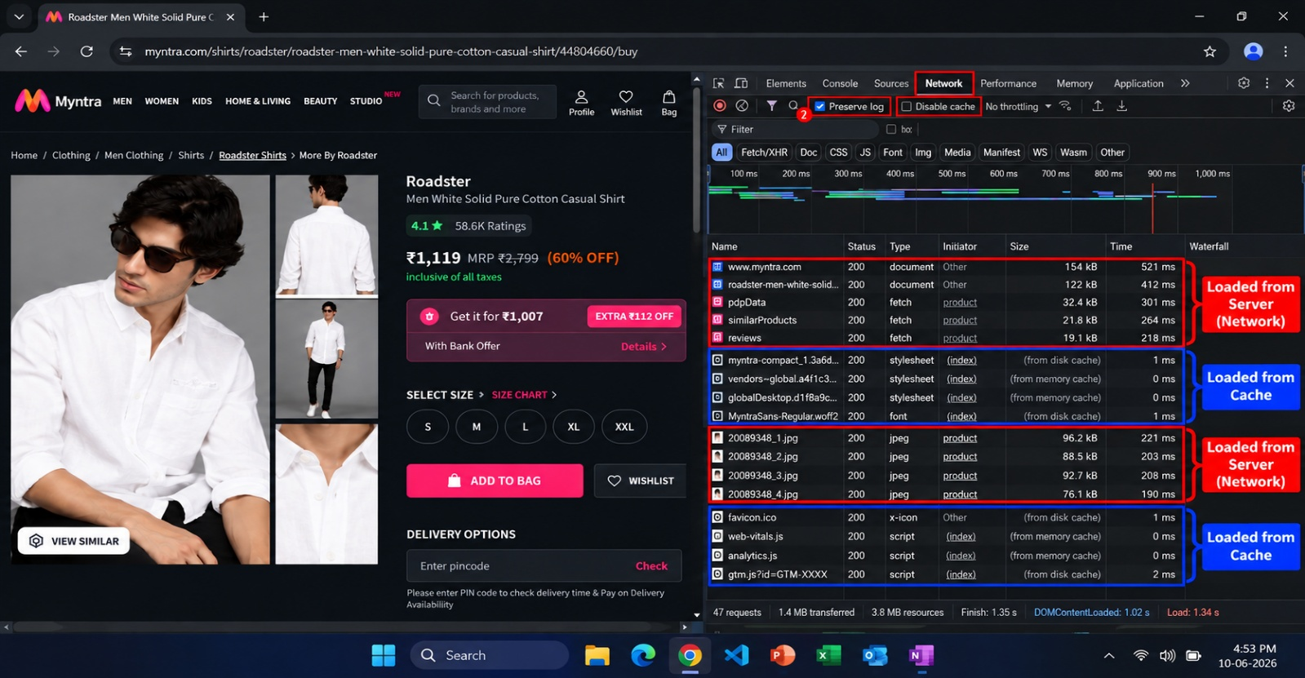
3. Screenshot – Dark Windows 11 / Myntra / Chrome DevTools

4. Server (Network) vs Cache Explanation

A. Server / Network
When a browser needs information that is not available in its cache, it sends a request over the network.
The request can go to the website's server or another server/CDN.
For example, when opening a Myntra product, the browser may request:
Browser → Internet → Myntra server → Browser
The server processes the request and sends the required information back.
Examples include:
- Product information
- Product details
- Product images
- Reviews
- Availability information
- API responses

Example
User clicks product
↓
Browser sends request
↓
Myntra server
↓
Server processes request
↓
Response sent to browser
↓
Product displayed

B. Browser Cache
A browser cache is temporary storage maintained by the browser.
When a resource has already been downloaded, the browser may store it locally.
If the same resource is required again, the browser can sometimes use the locally stored copy instead of downloading it again.
The cache can include:
- CSS files
- JavaScript files
- Fonts
- Images
- Icons
- Other website resources
Chrome can indicate cached resources using messages such as:
from memory cache
or
from disk cache

Example
Browser requests CSS
↓
Browser checks cache
↓
Resource already available
↓
Browser loads cached copy
↓
Page displays faster

Comparison: Server vs Cache
Feature | Server / Network | Browser Cache
Location | Remote server/network | User's computer
Internet communication | Usually required | Often not required for the cached copy
Download | Resource is transferred | Existing local copy is used
Speed | Depends on network/server | Usually faster
Example | Product API | Previously downloaded CSS
Purpose | Obtain current/needed data | Reuse previously stored resources

Why is caching useful?
Caching improves website performance.
For example, suppose a CSS file is 100 KB.
The first time the browser needs it, it may download it from the server.
Later, if the cached copy is still valid, the browser can use the local copy.
This can:
- Reduce network traffic.
- Reduce loading time.
- Reduce server requests.
- Improve the user experience.
- Make repeated page visits faster.

5. Short Conclusion
This task demonstrated how a browser communicates with a web server when accessing a website such as Myntra.
Using Chrome DevTools → Network, different requests made while opening a product page were observed. These requests included documents, API/fetch requests, images, CSS, JavaScript, and other resources.
The activity also demonstrated the difference between network/server-loaded resources and cached resources. Server-loaded resources require communication with the network, while cached resources can be retrieved from the browser's local memory or disk cache.
Therefore, Chrome DevTools Network is a useful tool for understanding how websites work, how browsers communicate with servers, and how caching improves website performance.

